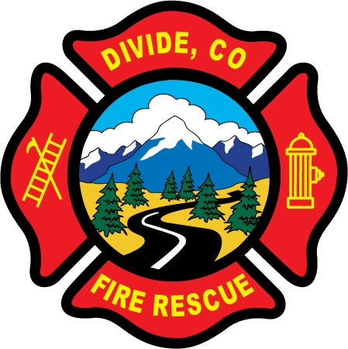
Divide Fire Protection District

Membership Application

Name:
Home#: Work#: Cell#:
Email:
Address:
Mailing Address:
City/State/Zip
Employer: Occupation:
Emergency Contact:
Name:
Address:
Phone:
Relation:
Alternate Contact if desired:

Length of time in Divide area______________________________________________________________________________

EMS/Fire/Rescue experience and certifications (if any):_________________________________________________________

_____________________________________________________________________________________________________

Do you have any type of medical condition that might limit your ability to perform during strenuous fire-fighting or rescue

operations? Yes ◻ No ◻ If yes, explain_____________________________________________________________

Do you hereby consent to undergo a drug test via urinalysis at the District’s expense as a pre-requisite to membership in

the District? Yes ◻ No ◻ Initial here: ______

Do you hereby give consent for the District to conduct an investigation of your driving and criminal history?

Yes ◻ No ◻ Initial here: ______

I understand volunteers must be at least 18 years of age (application may be made up to three months prior) and must possess a high school diploma or GED equivalent, unless they are currently enrolled in high school and pending graduation.

I hereby apply for membership in the Divide Fire Protection District and agree to abide by all of the District’s rules, regulations, and policies. I understand that providing false or inaccurate information on this application could be grounds for dismissal from the District at any time.

_____________________________________________________________________________________________________
Signature of Applicant Date

