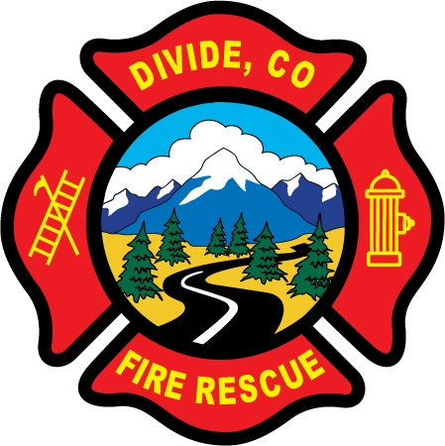 | Divide Fire Protection District  PO Box 941 Phone: 719-687-8773  103 Cedar Mountain Rd. E-Mail: dividefire@dividefire.com  Divide, CO 80814

Notice of Special Meeting
pursuant to CRS § 32-1-903(2):

The Divide Fire Protection District will hold a special meeting of the Board:

Date: Monday, June 3rd, 2024
Time: 6:30 p.m.
Place: Shoemaker Station, 103 Cedar Mountain Rd.

AGENDA

- Optional attendance of department business meeting (no District Board business to be conducted during department business meeting) Multiple board members may be in attendance.

